THE CODE 1 :
44 – 4 – 9 – 9
19 – 23 – 1 – 2
61 – 1 – 18 – 16
25 – 1 – 1 – 32
______ ______ ______ ______!

THE CODE 1 :
44 – 4 – 9 – 9
19 – 23 – 1 – 2
61 – 1 – 18 – 16
25 – 1 – 1 – 32
______ ______ ______ ______!

THE CODE 1 :
44 – 4 – 9 – 9
19 – 23 – 1 – 2
61 – 1 – 18 – 16
25 – 1 – 1 – 32
______ ______ ______ ______!

THE CODE 1 :
44 – 4 – 9 – 9
19 – 23 – 1 – 2
61 – 1 – 18 – 16
25 – 1 – 1 – 32
______ ______ ______ ______!

THE CODE 2 :
1 – 1 – 3 – 4
28 – 7 – 8 – 12
25 – 4 – 16 – 8
55 – 2 – 17 – 5
______ ______ ______ ______!
THE CODE 2 :
1 – 1 – 3 – 4
28 – 7 – 8 – 12
25 – 4 – 16 – 8
55 – 2 – 17 – 5
______ ______ ______ ______!

THE CODE 2 :
1 – 1 – 3 – 4
28 – 7 – 8 – 12
25 – 4 – 16 – 8
55 – 2 – 17 – 5
______ ______ ______ ______!

THE CODE 2 :
1 – 1 – 3 – 4
28 – 7 – 8 – 12
25 – 4 – 16 – 8
55 – 2 – 17 – 5
______ ______ ______ ______!

THE CODE 3 :
44 – 9 – 29 – 9
41 – 2 – 4 – 28
66 – 19 – 10 – 25
36 – 3 – 9 – 22
3 – 18 – 2 – 8
51 – 3 – 24 – 9
48 – 3 – 13 – 3
17 – 3 – 2 – 20
______ ______ ______ _____ _______ ______ ______ ______!

THE CODE 3 :
44 – 9 – 29 – 9
41 – 2 – 4 – 28
66 – 19 – 10 – 25
36 – 3 – 9 – 22
3 – 18 – 2 – 8
51 – 3 – 24 – 9
48 – 3 – 13 – 3
17 – 3 – 2 – 20
______ ______ ______ _____ _______ ______ ______ ______!

THE CODE 3 :
44 – 9 – 29 – 9
41 – 2 – 4 – 28
66 – 19 – 10 – 25
36 – 3 – 9 – 22
3 – 18 – 2 – 8
51 – 3 – 24 – 9
48 – 3 – 13 – 3
17 – 3 – 2 – 20
______ ______ ______ _____ _______ ______ ______ ______!

THE CODE 3 :
44 – 9 – 29 – 9
41 – 2 – 4 – 28
66 – 19 – 10 – 25
36 – 3 – 9 – 22
3 – 18 – 2 – 8
51 – 3 – 24 – 9
48 – 3 – 13 – 3
17 – 3 – 2 – 20
______ ______ ______ _____ _______ ______ ______ ______!


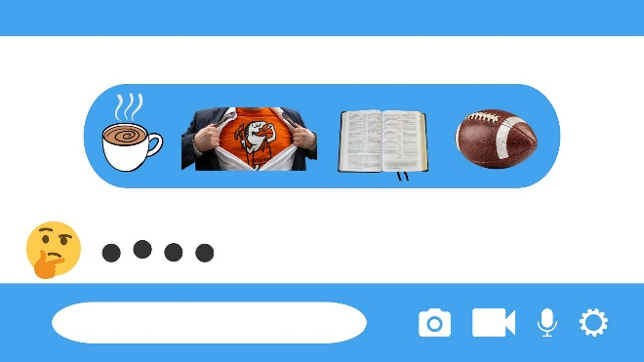

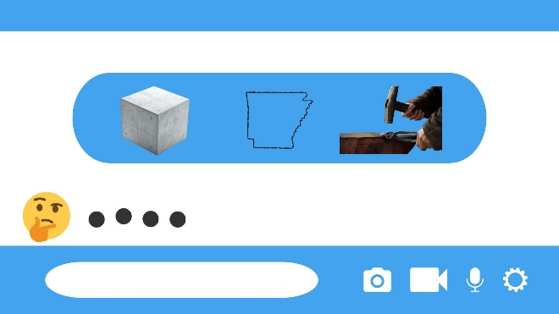
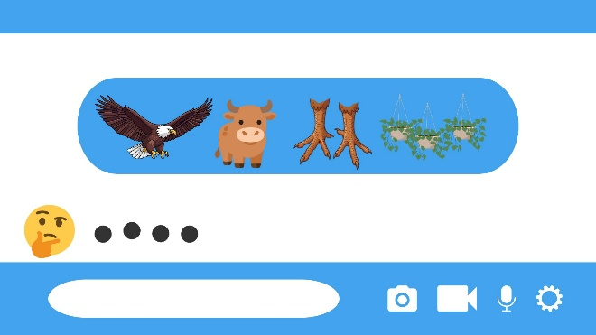
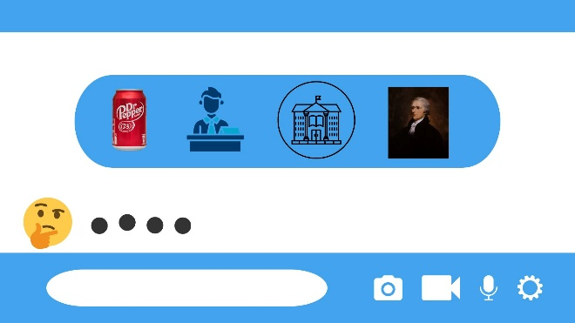
Acts (44) 4:9 (4)-(9) Word 9 (9) – GOOD
Psalm (19) 23:1 (23)-(1) Word 2 (1) – LORD
2 Peter (61) 1:18 (1)-(18) Word 16 (16) – THE
Lamentations (25) 1:1 (1)-(1) Word 32 (32) – IS
THE LORD IS GOOD
______ ______ ______ ______!

THE Answer 2 :
1 – 1 – 3 – 4 (let) Genesis
28 – 7 – 8 – 12 (cake) Hosea
25 – 4 – 16 – 14 (Them) Lamentation
55 – 2 – 17 – 5 (eat) 2 Timothy
Let Them Eat Cake
______ ______ ______ ______!
THE Answer 3 :
44 – 9 – 29 – 9 Acts (the)
41 – 2 – 4 – 28 Mark (Let)
66 – 19 – 10 – 25 Rev (of)
36 – 3 – 9 – 22 Zeph (Lord)
3 – 18 – 2 – 8 Lev (say)
51 – 3 – 24 – 9 Col (the)
48 – 3 – 13 – 3 Gal (Redeemed)
17 – 3 – 2 – 20 Est (so)
Let the Redeemed of the Lord Say SO
______ ______ ______ _____ _______ ______ ______ ______!
The Answer 4 : Caleb

King Nebuchadnezzar

Bro. Hamilton (A Youth Worker)

Bro. Dalton (A Youth Worker)

Bro. Caleb (YP)

